H.T No
Regulations:
A15

Sreenidhi Institute of Science and Technology
(An Autonomous Institution)
Code No: 5C301 Date: 03-Oct-2020 (FN)

B.Tech II-Year I-Semester External Examination, October - 2020 (Supplementary)
ELECTRONIC DEVICES AND CIRCUITS (EEE, ECE & ECM)

Time: 2 Hours Max.Marks:75

Note: a) No additional answer sheets will be provided.
b) All sub-parts of a question must be answered at one place only, otherwise it will not be valued.
c) Missing data can be assumed suitably.

ANSWER ANY FIVE QUESTIONS. EACH QUESTION CARRIES 15 MARKS.

1. | a) | Compare electrostatic and magnetic deflection methods. | [8M]
 | b) | It is found that an electron beam is deflected by 8 degrees when it transverses a uniform magnetic field, 3cm wide having a density of 0.5mT. Calculate the speed of the electrons and the force on each electron. The direction of beam is normal to that of the flux. | [7M]
2. | a) | Derive the ripple factor equation for Half wave rectifier. | [8M]
 | b) | Explain the operation of P-N diode in Forward and Reverse bias. | [7M]
3. | a) | Derive the stability factor for voltage divider bias. | [8M]
 | b) | Explain the input and output characteristics of CE configuration. | [7M]
4. | a) | A FET has a driven current of 4mA. If I_{DSS}​ = 8mA and V_{​GS(off)​} =​ -6V. Find the values  of V_{GS}​ and V​​_{P}.​ | [8M]
 | b) | Explain the characteristics of SCR. | [7M]
5. | a) | Derive the current gain, input impedance and voltage gain for CE transistor configuration using h-parameters. | [8M]
 | b) | Given that the hybrid parameters for the transistor are h_{ie}=1.5​KΩ, h_{​fe}=150​,  h_{re}​=1x10⁻⁴​ , h_{oe}​ =20μ℧. Draw the hybrid equivalent of transistor in CC configuration. | [7M]
6. | a) | Explain the operation of shunt voltage regulator. | [8M]
 | b) | Explain the need of current limiting circuit. | [7M]
7. | a) | Calculate Z_{in}, Z_{o} for the circuit shown. h​_{ie}=1.6​KΩ, h​_{fe}=110  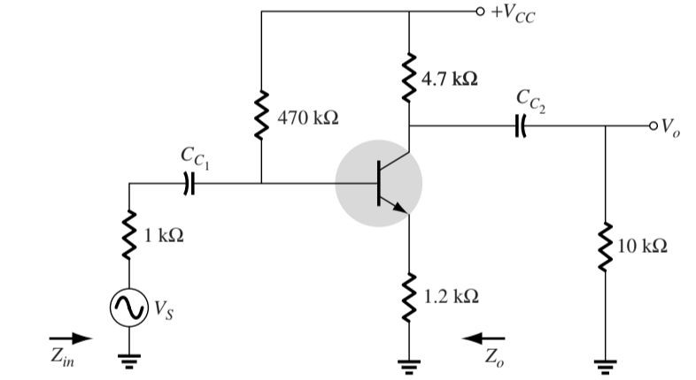 | [8M]
 | b) | Mention the applications of UJT. | [7M]
8. | a) | Explain the Zener diode characteristics. | [8M]
 | b) | Draw the block diagram of CRT and explain. | [7M]

-- 00 -- 00 –

